**CLOUD COMPUTING DAY-2 QUESTIONS**

**VM WARE(HYPERVISE-2) STATION**

9.create a Snapshot of a VM and Test it by loading the Previous Version/Cloned VM

Procedure:

1.Before taking snapshot of normal vm

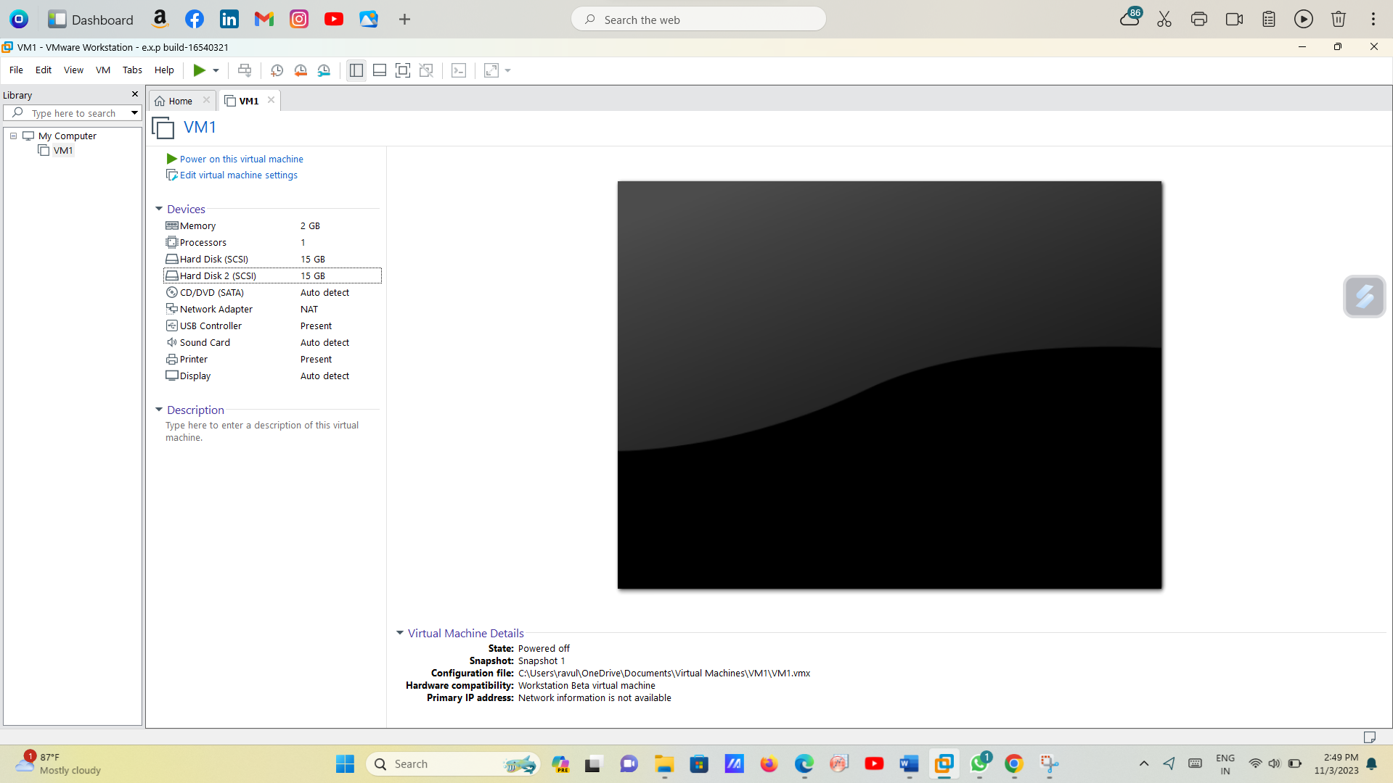

Snapshot 1 vm ware.

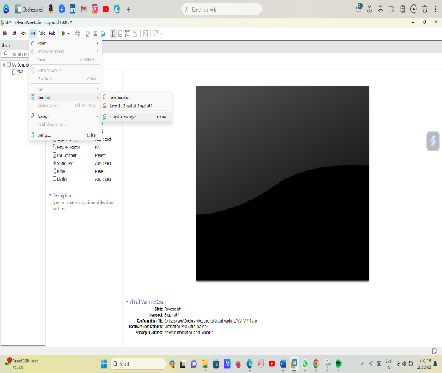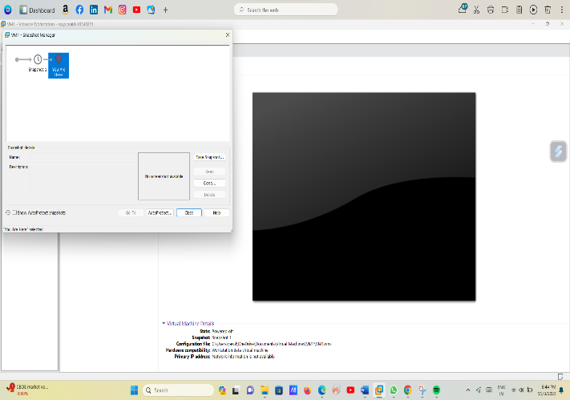

2.Move snapshot option and move snapshot manager on that open the previous version or hardware options.

After remove one harddisk and take one snapshot.

And take to move the before snap shot.

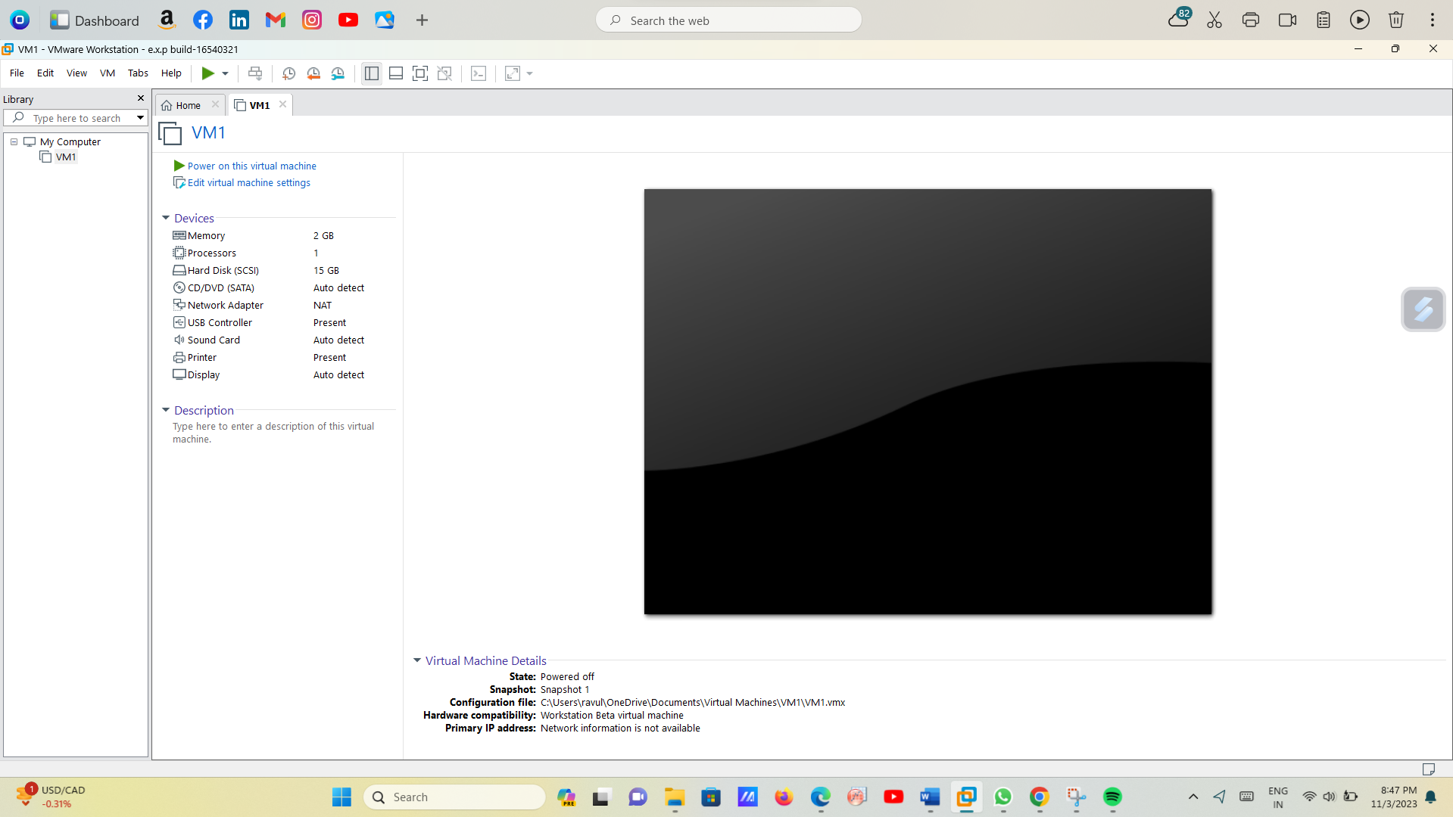

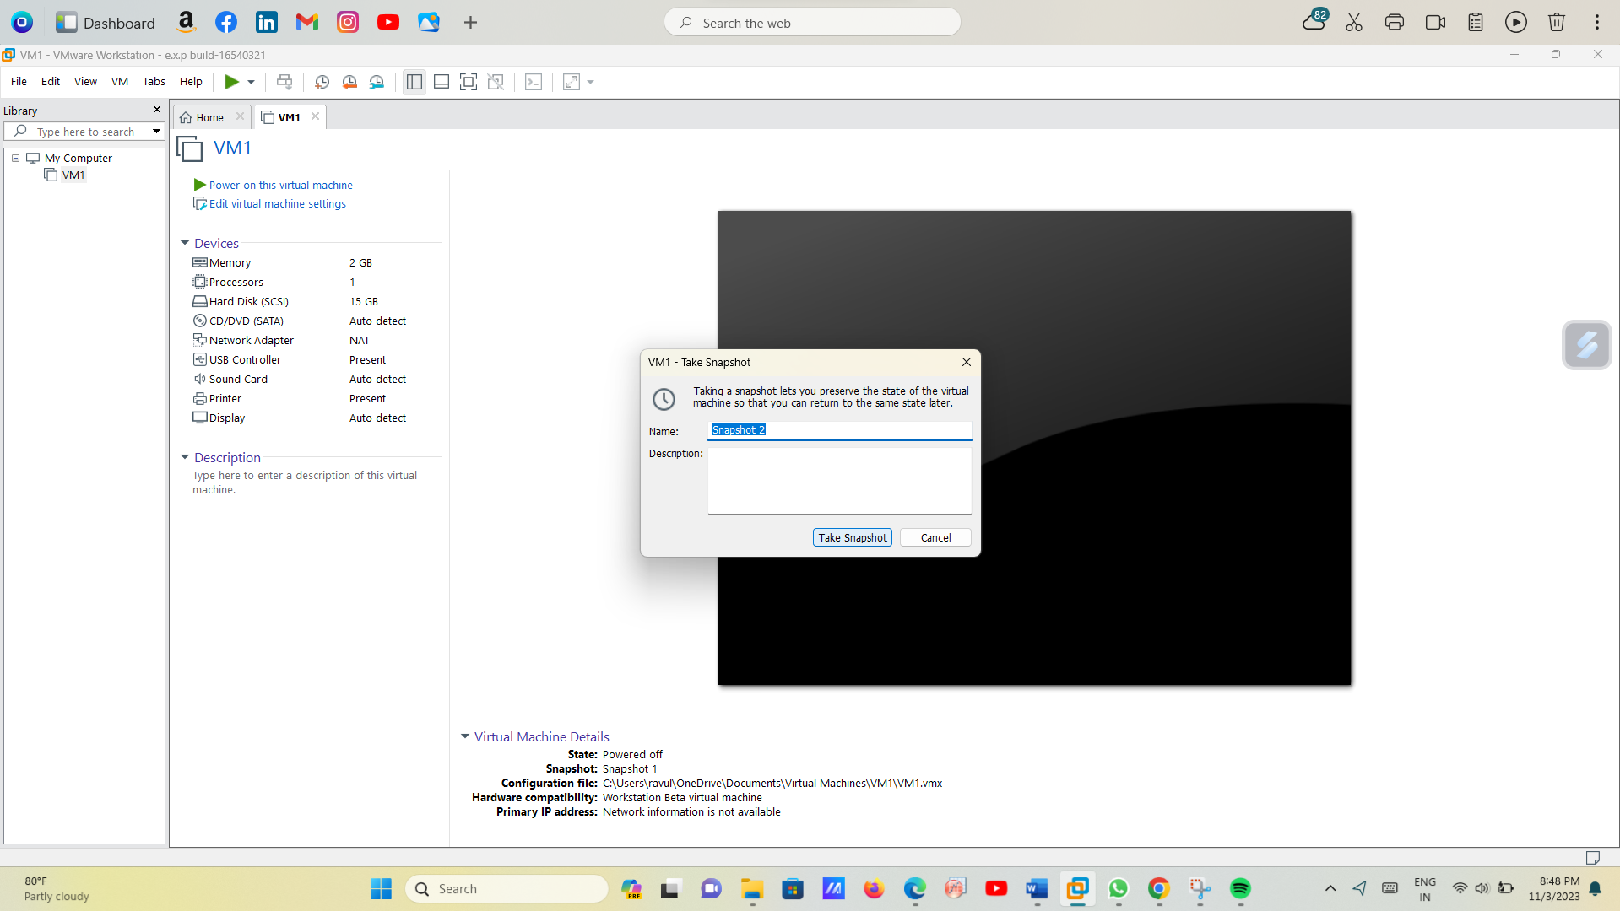

3.Before select the previous snapshot and go snapshot manager and select.

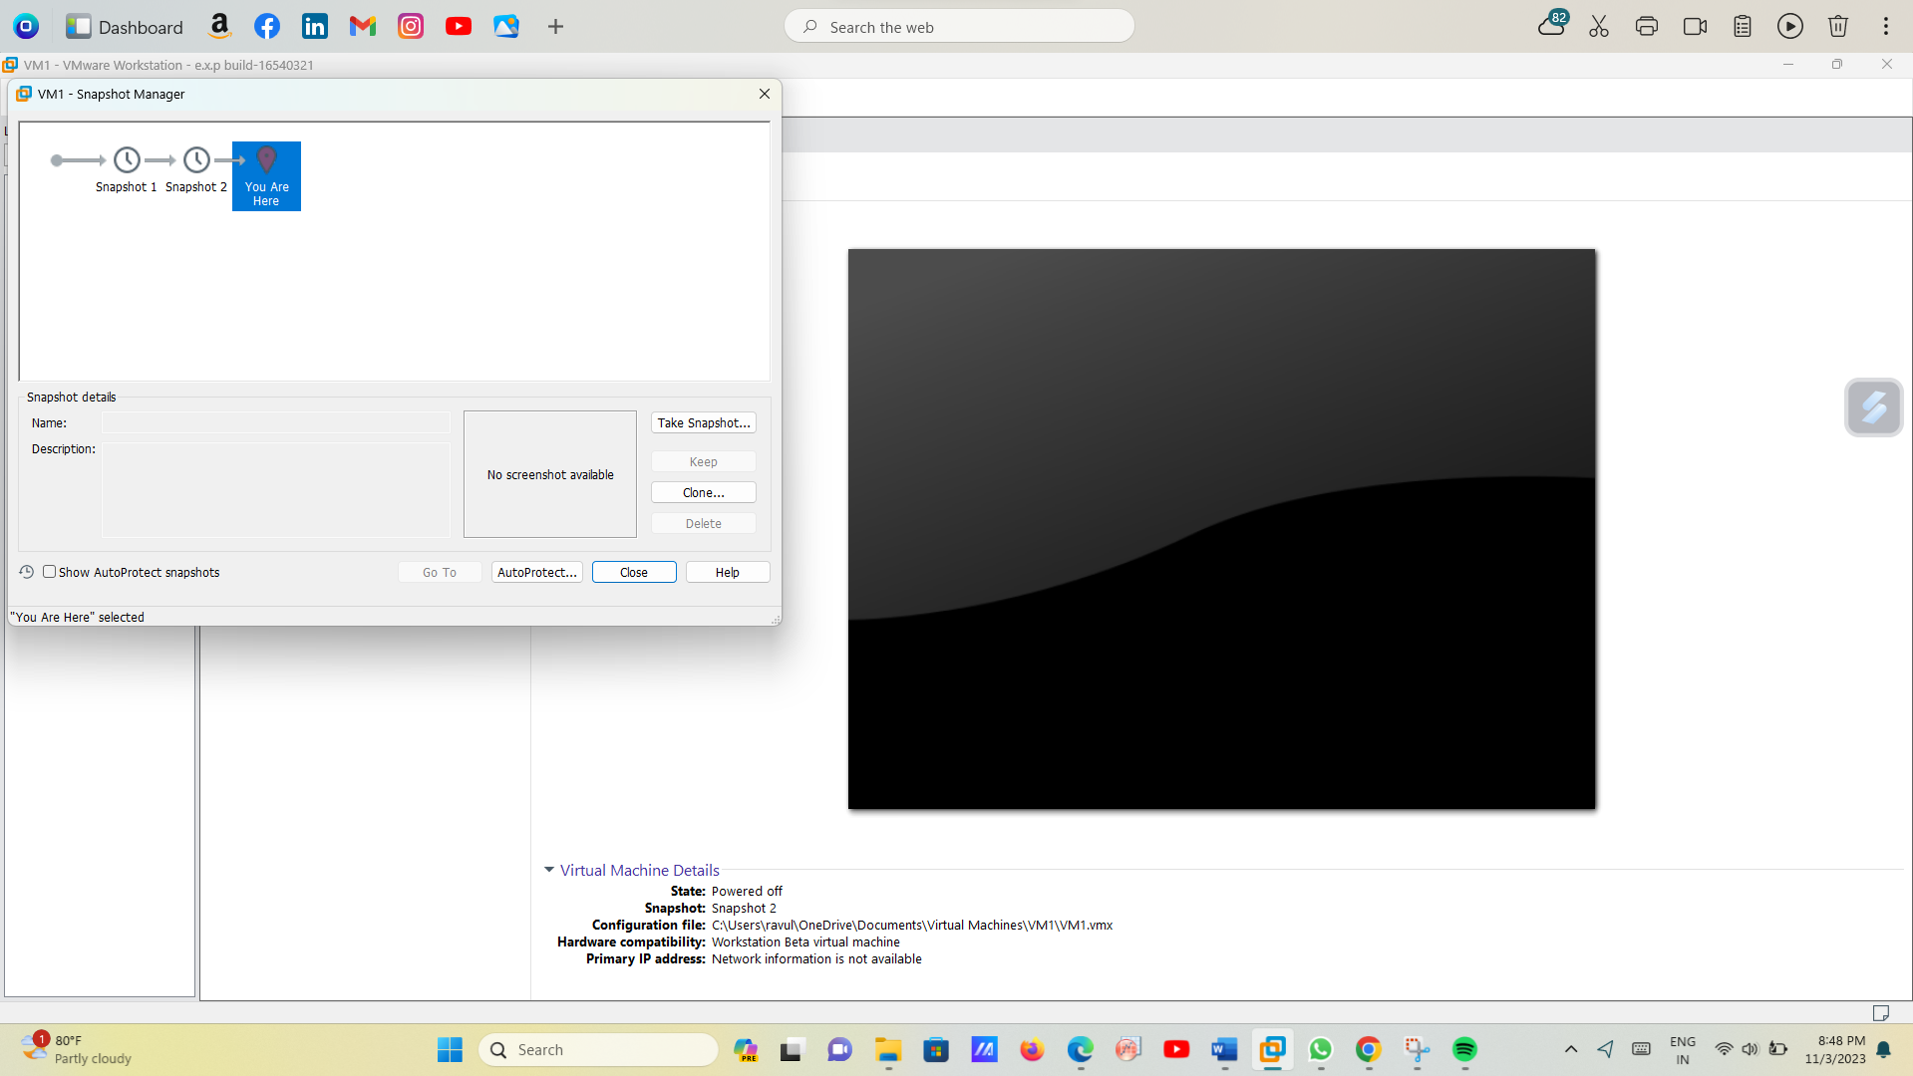

4.And after choose the previous snapshot vm ware and give the warning msg and to give yes option for to move the beforesnapshot.

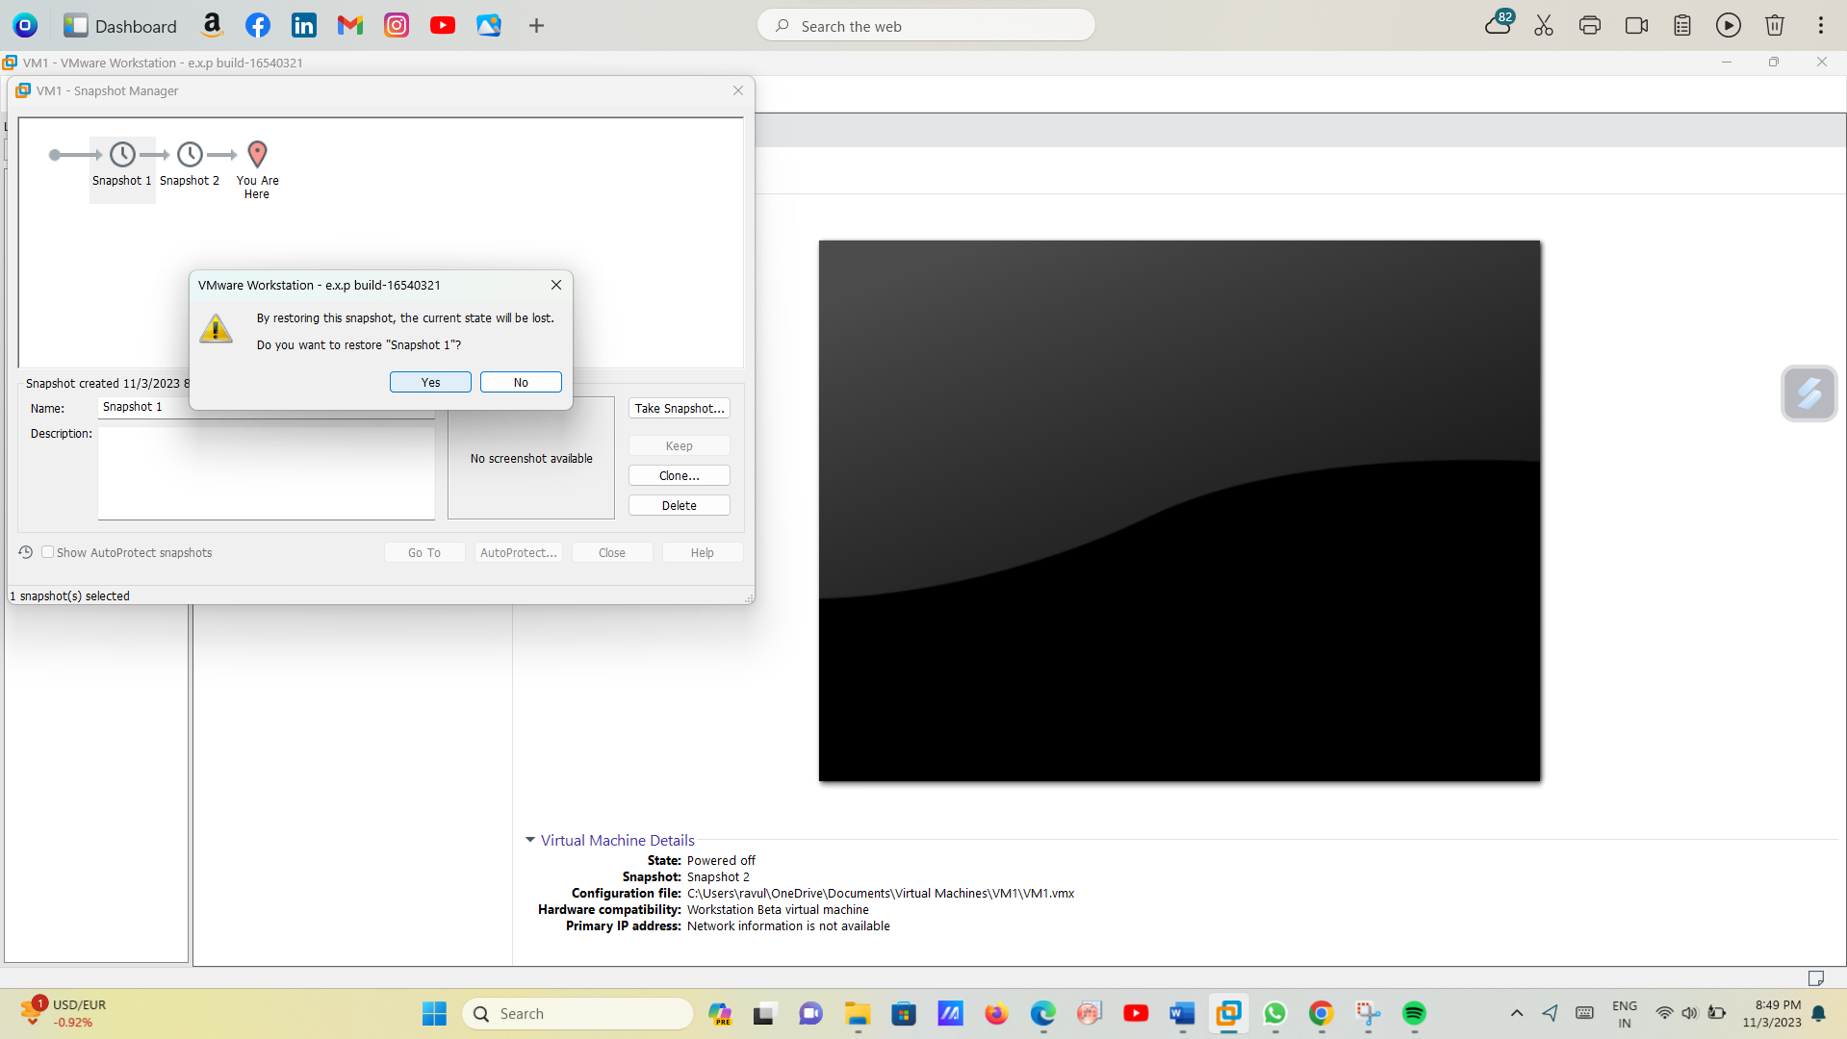

5.This is the original snapshot1.

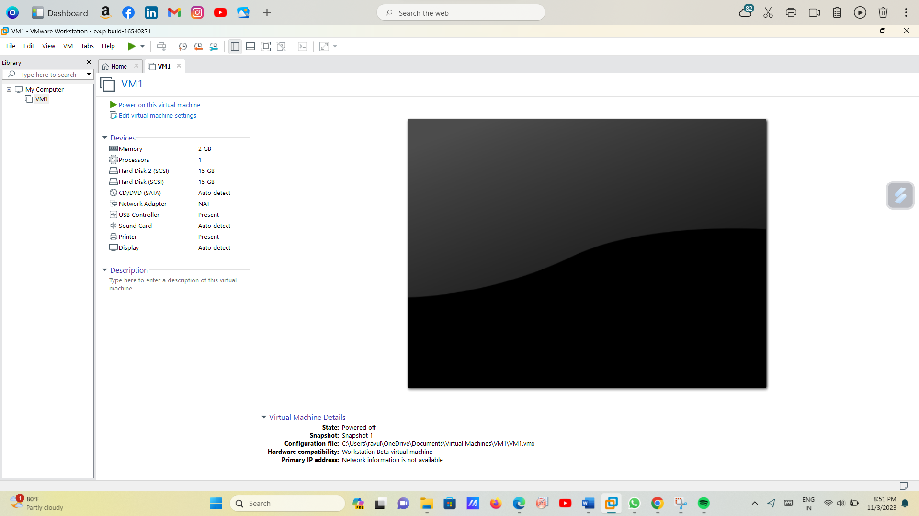

6.This is the hardware design for the virtual machine design.

